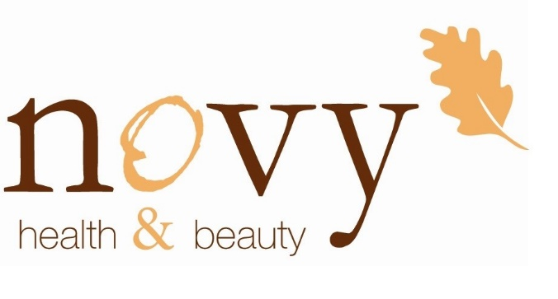

Name:_______________________________________

Telephone:____________________________________ Email: ______________________________

Date: _______________________________________ Signature: ___________________________

Your Data Protection Consents

We are committed to helping you with your health and beauty needs. The information you have provided helps us to make our time together as effective as possible so that we can tailor your treatment to best suit you so you can relax and enjoy the treatment you deserve

How the information about you will be used

We will not share any information you give us with anyone else. We keep our records for 7 years
You are welcome to see the information we have on you. Just ask in person, by telephone (07889 744348) or via email – novy@live.co.uk.
You have the right to withdrawn your consent at any time by letting Joanne know either in person, by telephone (07889 744348) or via email – novy@live.co.uk

Consent to let us keep in touch

We send all appointment reminders by text and email is that OK with you?
- Yes, I consent
- Text only
- Email only
- No thanks

Occasionally we would like to send you information and offers is that OK with you?
- Yes please, I would like to receive communications via email
- Yes please, I would like to receive communcations via telephone
- Yes please, I would like to receive communcations via Mobile (text messages, Messenger)
- Yes please, I would like to receive information via post
- No thank you. I do not wish to receive information.

Thank you

